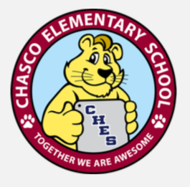
We need you for:
The Great American Teach- In
Wednesday, November 13th
We need parents, friends, and community members who would be interested in sharing their work experiences with the next generation of workers.
If you, or anyone you know, is interested in visiting Chasco Elementary School to participate in The Great American Teach In, please fill out the information below and return it to the school as soon as possible.
Point of Contact: blaroche@pasco.k12.fl.us Thank you!
_________________________________________________________________
GREAT AMERICA TEACH-IN PRESENTER FORM
Presentations are scheduled in 30 min blocks, but can be as long as needed.
Please fill out and return to the school by Friday, November 1, 2019.
Name: _____________________________________________Phone: (_____)_____________________
Times available: ________________Number of Presentations: ____________(Between 10 to 1:00)
Topic or Career:_________________________________________________________________________
Preferred Grade Level :(Circle) K-2 or 3- 5
Special items, equipment or location needed for presentation:_____________________ ____________________________________________________________________________________________

