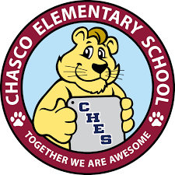  Chasco Elementary Flea Market  Saturday, November 16th from 8am-2pm in the Chasco Elementary car loop.  Come and sell, or come out and shop.  Please submit payment of $25.00 and this form to the Chasco Elementary School office no later than November 8th.  Name: ___________________________________________________  Phone: ___________________________________________________  Number of tables: __________. Amount Paid: ____________________ | Tables are $25.00 and measure 8’x 28”. Only 40 tables available. You keep all the money from sales at your booth.  Items for sale must be within the guidelines of the district’s code of conduct while on school grounds.  Help support our 5th grade students through a great community event!

