Chasco Elementary School
3rd Grade Supply List
2021-2022

- 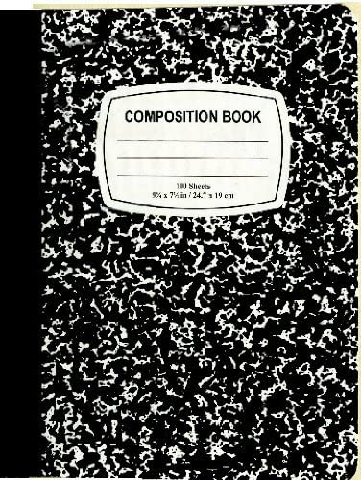6 black marble composition books (100-page count)
- 4 2-pocket pronged folders (any color)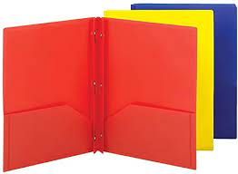
- 1 large pencil box
- 1 pair of scissors
- 24 pencils
- 1 box of Crayola 12 count-colored pencils
- 1 box of Crayola 10 count markers
- 1 box of Crayola 16 or 24 count crayons
- 2 packs of glue sticks
- 1 package of Large Expo markers
- 1 package of thin Expo markers
- 1 container of Clorox or Lysol wipes
- 1 box of Tissues

Please ONLY label the supply box with your child’s name.

